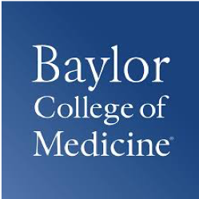
ARE YOU A PARENT OF A CHILD WITH OCD?

WE ARE RECRUITING PARTICIPANTS FOR A STUDY to learn about the experiences of people who have conditions for which pediatric deep brain stimulation (pDBS) is available or conditions for which pDBS may be available in the future. You and/or your child are being asked to participate so that we can learn what caregivers and children with OCD think about this technology.
Participation would involve a short questionnaire and 60-minute interview for each the caregiver and the child/adolescent, separately. We will compensate participants with a $50 Amazon gift card for completing the questionnaire and interview.
We are seeking:
- Parents of children with sustained OCD symptoms even after treatment.
- Children and adolescents with sustained OCD symptoms even after treatment who are between the ages of 11 and 17.
Interviews may be done by phone, via videoconference, or in person.
To schedule an interview or for more information, please contact Katrina Munoz at katrina.munoz@bcm.edu or at 713-798-1726.

This study is funded by the National Institutes of Health: RF1MH121371
Principal Investigators: Drs. Gabriel Lázaro-Muñoz, Eric A. Storch, Jennifer Blumenthal-Barby from Baylor College of Medicine

